Pickleball Handout
History
• Pickleball was founded in the summer of 1965, on Bainbridge Island in the Puget Sound area of
Washington.
• Two US Congressman, Bill Bell and Joel Pritchard invented a game.
• The game started on an asphalt badminton court in Pritchard’s backyard.
• Without a shuttlecock to play badminton with, 2 men quickly improvised with a Wiffle-type ball.
• It was difficult to hit the 3-inch ball with the lightweight rackets. Instead of using the badminton racquets they decided to use wooden ping-pong paddles.
• As the game evolved it was determined that players could hit the ball on the bounce as well as out of the air and they lowered the net from five feet (badminton height) to three feet (tennis height).
• The game was named after the Pritchard family dog, a cocker spaniel named Pickles. Whenever the ball would travel off the court the dog Pickles will take it and hide with it.
• The next weekend they introduced pickleball to friend Barney McCallum and together the three men wrote down the first official rules of the game.
Court Dimensions
• The Pickle-Ball court is identical to a doubles badminton court: 20’ x 44’.
• The net is hung at 36 inches.
Equipment
• The game of pickleball is played with a wooden paddle, plastic ball, and a badminton court.
Serve
• Player must keep one foot behind the back line when serving.
• The serve is made underhand.
• The paddle must pass below the waist.
• The server must hit the ball in the air on the serve, the server is NOT allowed to bounce the ball and then serve it.
• The serve is made diagonally cross-court and must clear the non-volley zone.
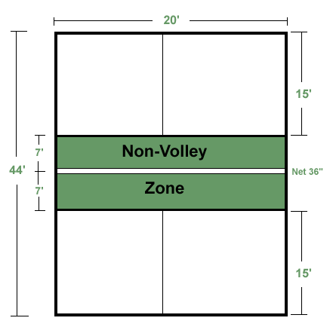
• Only one serve is allowed, unless the ball touches the net and lands in the proper service court (then serve is taken over). This is called a “let”.
• A result of a “let” is a redo without penalty and no change in score

SERVER LINE
Serve diagonally

During Doubles play
• At the start of each new game, the 1st serving team is allowed only one fault before giving up the ball to the opponents. Thereafter both members of each team will serve and fault before the serve is turned over to the opposition.
• When the serving team wins a point, its players will switch right and left sides of the court and the same player will continue to serve until the serving team makes a fault.
• When the serving team makes its first fault, the players will stay in the same court (right / left) and the second partner will then serve (unless it is the very first service of the game).
• When they make their second fault they will stay in the same courts (right / left) and give the ball over to the other team.
• Players only switch right and left sides of the court when they score a point.
• The serve always begins on the right side.
• Any ball landing on a line is considered to be good and in play.

Singles Play
• All of the “Doubles Rules” apply with the following exception: When serving in singles, each player
serves from the Right Hand court when his/her score is 0 or an even number and from the left hand court when his/her score is an odd number.

Non-Volley Zone / Rule
• The non-volley zone rule is unique to Pickleball. This rule states that at anytime, a player cannot volley a ball while standing on or in front of the “non volley zone line”
• To volley a ball means to hit the ball in the air before the ball bounces.
• It is a fault if the player steps over the line on his/her volley follow-through.

Double Bounce Rule
• Each team must play their first shot after serve off the bounce.
• The receiving team must let the serve bounce before returning the ball and the serving team must play the initial return off the bounce.
• After the double bounce rule, players may choose to volley or play the ball off the bounce.
Faults
• Hitting the ball out of bounds.
• Hitting the ball into the net.
• Stepping into the non-volley zone and volleying the ball.
• Volleying the ball before it has bounced once on each side of the net as outlined by the Double bounce rule.
Scoring
• A team shall score a point only when they are the serving team.
• A player who is serving should continue to serve until his team makes a fault.
• The game is played to 11 points; a team must win by two points.
Pickle-Ball Strategies
• Pickle-Ball involves a variety of shots such as lobbing, overhead slamming, passing drive shots from the baseline, drop shots, and fast volley exchanges.
• The key strategy is to be the first player or team to reach the forecourt (area of the court just outside of the non-volley zone) in a net volley position; the team that gets in position first generally wins the point.
• During doubles the most effective positioning appears to be when both players are side-by-side in the attack position just behind the non-volley zone line.

